
Series 1: Patterns in the Sky
Lesson 1: Tabulating Data 1
Student Activity Booklet

Context:
Astronomical data is information collected through observing the sky and space. Scientists have been collecting data about the Sun, Moon, stars, and planets for thousands of years.
Aboriginal and Torres Strait Islander Peoples are the world's oldest astronomers. They observed and recorded patterns in the sky for over 65,000 years, using this knowledge to predict seasons, plan hunting and gathering, and navigate.
In this lesson you will learn to tabulate and extract information from real astronomical data collected from a range of trusted sources.

Learning Intention
In this lesson you will tabulate and extract useful information from data.
Success Criteria |  | Check
 | By the end of this lesson, I will be able to:
 | - organise sunrise/sunset data in a table with clear headings and units | ◻
 | - design a data table and enter the appropriate data | ◻
 | - carry out simple calculations from the data (daylight length, time differences, average day length)  - extract useful information from data | ◻  ◻

Question 1

Think about your daily life and how you obtain information from data. For example, seeing how many views or likes your social media posts get, checking how much time you spend on your phone each day, or looking at your music app's yearly summary to see your most-played songs. All of these involve collecting and organising information to help us make decisions or understand patterns.

In your own words, explain why you think scientists need to collect and organize information (data) to understand the world around us. Give one example from your everyday life where organized information helps you make better decisions.

Designing Data Tables

Read through the following information.
Scientists use data tables to organise observations and measurements in a clear and structured way. By doing this, measurements and units are kept in the same place every time, the data is easier to analyse, and trends or patterns are easier to see.

A checklist with some key features and instructions to follow when designing data tables in science is below.
Key Feature
- Title: State what is changed and the effect on what is measured.
- Column headings: Name each quantity (variable) and include units
- Units: write units in the headings only, not with each recorded value.
- Left column: Place the variable that changes (independent variable).
- Right column(s): Place the variable or variables that were measured in response (dependent variable).
- Data rows: Use one row for each observation, and make sure every number is lined up under the correct heading.
- Placement check: Ensure every entry is in the right place in its row and column. Do not leave blank cells. Instead use “-” or “n/a” if there is no value to enter.
- Additional columns: Add columns on the right for calculated (summary) values such as averages, range, or percentage change.
- Setting Out: Use clear, ruled lines or simple gridlines and consistent borders. Keep text legible and avoid cramped cells.

Question 2
Use the data tabulation guidelines on Page 2 to label the key features (a) – (f) on the table below. The first one, (a) Title, has been completed for you.
- ____________________
____________________
- ___________________
___________________

- Title
- __________
_____________

- ___________
____________
- __________
____________
Average 2024 monthly minimum and maximum temperatures for Wagga Wagga, NSW
Month | Average daily minimum temperature (°C) | Average daily maximum temperature (°C)
January | 16.5 | 31.9
February | 16.4 | 31.0
March | 13.6 | 27.8
April | 9.2 | 22.6
May | 5.9 | 17.4
June | 3.7 | 13.9
July | 2.8 | 12.8
August | 3.5 | 14.6
September | 4.6 | 19.4
October | 8.4 | 24.4
November | 14.4 | 29.3
December | 15.5 | 31.6
Table 1: Average monthly temperatures for Wagga Wagga, NSW
Question 3
- State the independent variable displayed in this table.

- State the dependent variables displayed in this table.

- State the units for temperature. Give the name and symbol.
Name: ______________________________________
Symbol: ______________________________________

- State the location (where) the data was collected.

- State the year (when) the data was collected.

- State the highest temperature recorded. Remember to include units!

- State the lowest temperature recorded, including units.

Tabulating data
Read through the following information and answer the questions that follow.
Kalina is 12 years old and lives in Dubbo, on Wiradjuri Country. For a summer science project, Kalina decides to record sunrise and sunset for one school week in January. Each morning, she watches the eastern horizon from her backyard and notes the time on the family kitchen clock when the top edge of the Sun first appears. Each evening, she notes the time when the last edge of the Sun disappears behind the western horizon. She writes both times in her science journal. She then prepares to place the data into a table so she can calculate daylight hours and look for patterns across the week.
Kalina’s data is recorded in her journal below:
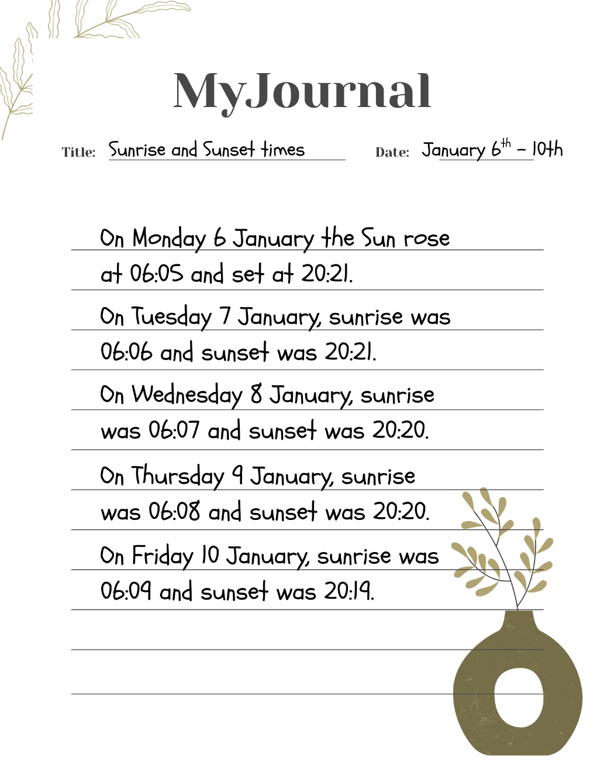
Image 1: Page from Kalina’s journal showing sunrise and sunset times

Question 4
- Using the guidelines for creating data tables, enter the data from Kalina’s journal into the first three columns on the left-hand side of the table below. The first set of data has been entered for you.

Dubbo Sunrise and Sunset Times between January 6th and 10th.
Date (January) | Sunrise time  (hours: min) | Sunset time  (hours: min) | Minutes of daylight (min) | Daylight length  (hours: min)
6 | 6:05 | 20:21 | 856 | 14:16
Table 2: Dubbo Sunrise and Sunset Times

- Calculate the daylight minutes and enter this into the “Minutes of daylight” column. The first row has been done for you.
Hint: To do this,
- Convert sunrise and sunset times into minutes after midnight.
E.g. For the time 6:05: There are 60 minutes in an hour, so 6 hours x 60 minutes = 360 minutes. Then add the extra 5 minutes. This can be written (6 x 60) + 5 = 365 minutes.
- Subtract sunrise minutes from sunset minutes. E.g. 1221 – 365 = 856 minutes

- Calculate the daylight hours and minutes and enter this into the “Hours and minutes of daylight” column in the table on page 2. The first row has been done for you.
Hint: To do this, divide your number of minutes by 60 (there are 60 minutes in one hour).
E.g. 856 ÷ 60 = 14 hours remainder 16 = 14 hours and 16 minutes

- Review the data table to find the date for the longest day between January 6th and January 10th.
________________________________________________________________________________________
- Review the data table to find the date for the shortest day between January 6th and January 10th.
________________________________________________________________________________________
- Calculate the average daylight hours and minutes over 5 days from January 6th – January 10th.
________________________________________________________________________________________
Hint:
- Add the five daylight values in minutes.
- Divide the total by 5 to get the average minutes.
- Convert average minutes to hours and minutes

- Kalina does some online research into moonrise and moonset times in Dubbo, NSW, using the Bureau of Meteorology website. Read through the information Kalina gathers, provided in the box below, and design a data table displaying this information in the space provided below.

- Sat 6 Jan 2024: moonrise 1:29 am, moonset 3:05 pm.
- Sun 7 Jan 2024: moonrise 1:59 am, moonset 4:07 pm.
- Mon 8 Jan 2024: moonrise 2:35 am, moonset 5:12 pm.
- Tue 9 Jan 2024: moonrise 3:18 am, moonset 6:19 pm.
- Wed 10 Jan 2024: moonrise 4:11 am, moonset 7:24 pm.

Design your table in the space provided below. Use the checklist given at the bottom of the page and check off each box as you go.

Title:
Key Feature | Check
Title  Column headings  Units  Left column  Right column(s)  Data rows  Placement check  Additional columns  Setting Out | ◻  ◻  ◻  ◻  ◻  ◻  ◻  ◻  ◻

Indigenous Scientific Knowledge
Read through the following information and answer the questions that follow.
For over 65,000 years, Aboriginal and Torres Strait Islander peoples across Australia have created precise seasonal calendars through systematic sky observations - making them the world's oldest continuous astronomers and scientists.
Aboriginal astronomical science includes:
- Precise tracking of daylight patterns to optimize travel, ceremony, and resource management
- Complex understanding of seasonal cycles for food security and environmental prediction
- Detailed star maps and celestial navigation systems for long-distance travel
- Multi-generational data collection and knowledge validation systems
Source: Hamacher, D., & Anderson, G. M. (2023). The First Astronomers: How Indigenous Elders Read the Stars. (1st ed.). Allen & Unwin.

Question 5
Using the sunrise/sunset data you have tabulated, discuss with a partner:
- How do longer daylight hours in January demonstrate the scientific precision needed for traditional resource management and travel planning?
___________________________________________________________________________________________
___________________________________________________________________________________________
___________________________________________________________________________________________
- Why would accurate seasonal prediction systems be essential for sustainable living practices?
___________________________________________________________________________________________
___________________________________________________________________________________________
___________________________________________________________________________________________
Reflection
- Write one sentence explaining how Kalina's data collection methods parallel the systematic observation approaches used by Aboriginal scientists for millennia.

___________________________________________________________________________________________
___________________________________________________________________________________________
___________________________________________________________________________________________

Interpreting Tabulated Data
The data below shows sunrise and sunset times for the 15th day of each month in Sydney, NSW.

2024 Sunrise and Sunset Times for the 15th day of each month for Sydney, NSW
Month | Sunrise Time | Sunset Time | Daylight Hours*
January (mid-summer) | 5:55 AM | 8:05 PM
February | 6:20 AM | 7:45 PM
March | 6:45 AM | 7:05 PM
April | 7:10 AM | 6:15 PM
May | 7:35 AM | 5:35 PM
June (mid-winter) | 7:55 AM | 5:25 PM
July | 7:50 AM | 5:35 PM
August | 7:20 AM | 5:55 PM
September | 6:40 AM | 6:15 PM
October | 5:55 AM | 6:40 PM
November | 5:20 AM | 7:05 PM
December | 5:35 AM | 7:35 PM
Table 3: Sunrise and Sunset Times on 15th day of every month

Question 6
- For Table 3 (above) calculate the number of daylight hours between sunrise and sunset and write your answer under “daylight hours”.
Hint: *Daylight hours = time between sunrise and sunset (in hours).
Use the example in Question 4 (b) on Page 5 to remind yourself about how to do this.

- Looking at Table 1, state the thing that changes (Independent Variable) and the value that has been measured (Dependent Variable).

Independent Variable: __________________________________________________________________
Dependent Variable: __________________________________________________________________

- In which month does the Sun rise earliest? _______________________________________________________________________________________________

- In which month is there the LEAST daylight?
_______________________________________________________________________________________________

- In which month is there the MOST daylight?
_______________________________________________________________________________________________

- Using data from the table, compare the data for December/ January with the data for June/ July and explain how this relates to the seasons and the position of the Earth relative to the Sun.
_____________________________________________________________________________________________
_____________________________________________________________________________________________
- Calculate the difference in daylight hours for January (summer) and June (winter):
Difference in daylight hours = ________ hours - ________ hours = ________ hours
Explain what this tells you about Australian seasons.
_____________________________________________________________________________________________
_____________________________________________________________________________________________
_____________________________________________________________________________________________
_____________________________________________________________________________________________
_____________________________________________________________________________________________

