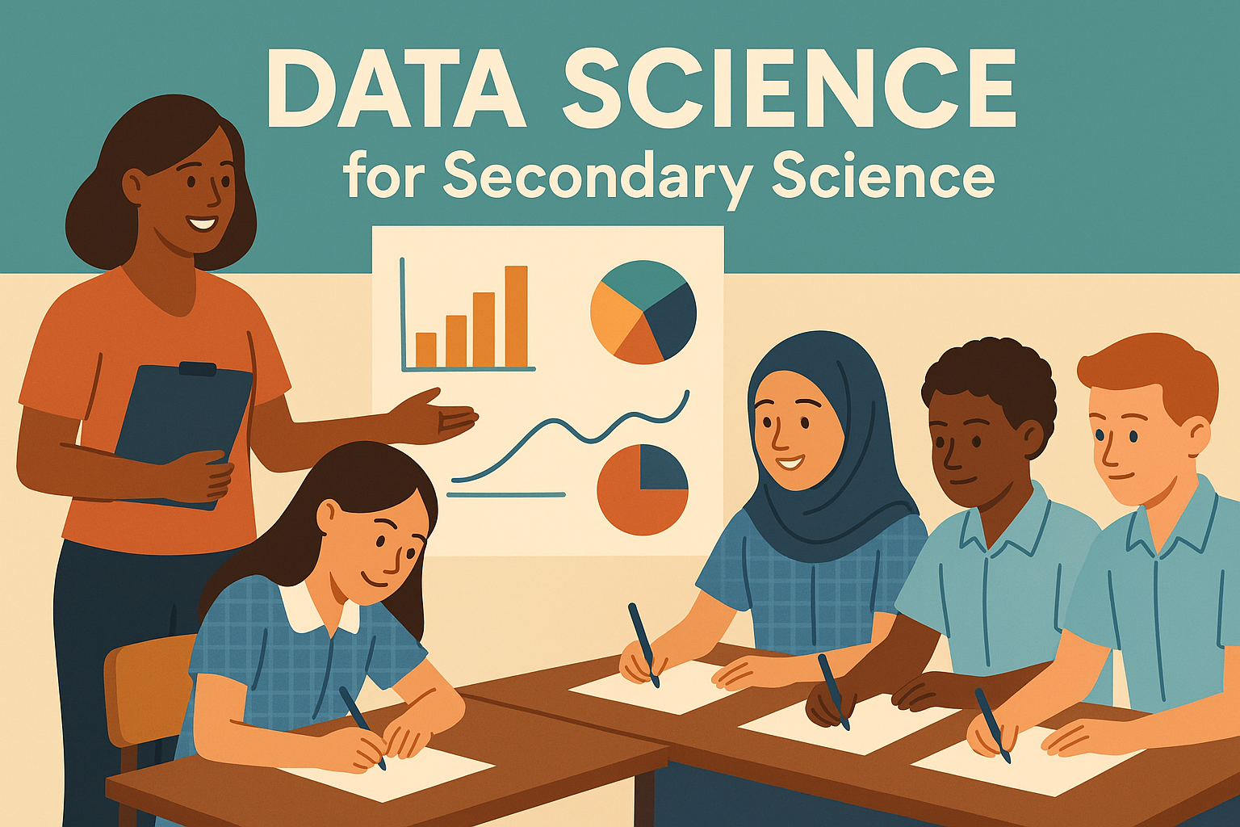
Series 1: Patterns in the Sky
Lesson 1: Tabulating Data 1
Teacher Guidelines, Sample Answers
and Follow-up Activities
This lesson integrates NESA Stage 4 “Data Science 1” focus area outcomes with “Observing the Universe” focus area outcomes. The key focus of the lesson is for students to tabulate and process data so that they can extract information from the data. The lesson is part of an 8-part lesson series that The Science Teachers Association of NSW will be releasing for members, in December 2025.

This lesson has been designed for use by high school teachers, whether they teach science or not, including casual teachers. The student worksheets have been written so that students can work with minimal teacher-instruction, although teachers using these worksheets may like to differentiate the student worksheet and accompanying teacher guidelines to make the student activities accessible and inclusive for the diverse range of students in their class.

The student activity, including learning intentions and success criteria, are targeted at students working at Grade C or standard on the NESA Year 1 to 10 common grade scale:
The student has a sound knowledge and understanding of the main areas of content and has achieved an adequate level of competence in the processes and skills.
Differentiation suggestions have been provided in the teacher resource for a range of students, for example gifted and high-potential learners, as well as students who would benefit from additional support to make the learning opportunity more accessible.

Feedback on how this resource could be improved for use in classrooms is welcome and can be provided via this form.

APPROACH TO ABORIGINAL AND TORRES STRAIT ISLANDER PERSPECTIVES
The Science Teachers' Association of NSW would like to acknowledge the Traditional Custodians of the various lands where this resource is being used.

We pay our respects to Elders past, present and emerging, and recognise and celebrate the diversity of Aboriginal peoples and their ongoing cultures and connections to the lands and waters of NSW.

This lesson has been designed to incorporate Aboriginal and Torres Strait Islander perspectives through a knowledge-sovereignty approach that positions Indigenous astronomical knowledge as sophisticated science equal to contemporary Western approaches. This lesson aims to reflect how Aboriginal peoples have employed rigorous scientific methods including systematic observation, pattern recognition, prediction, and multi-generational knowledge validation for over 65,000 years, making them the world's oldest continuous astronomers. We have aimed to use respectful language that describes Aboriginal practices with scientific terminology, avoids cultural appropriation by referencing well-documented general practices rather than specific cultural protocols, and encourages students to recognise Aboriginal peoples as scientists and innovators. This approach directly addresses NESA Science 7-10 (2023) requirements while supporting critical thinking, cultural competency, and learning that values multiple knowledge systems as foundational to scientific understanding.
LESSON OVERVIEW
- Duration: 60 minutes
- Year Level: 7-8 (Stage 4)
- Subject: Science - Data Science Focus

LEARNING INTENTION & SUCCESS CRITERIA
Learning Intention: In this lesson students will tabulate and extract useful information from data
Success Criteria:
- Organise sunrise/sunset data in a table with clear headings and units.
- Design a data table and enter the appropriate data.
- Carry out simple calculations from the data (daylight length, time differences, average day length).
- Extract useful information from data.

NESA STAGE 4 SCIENCE SYLLABUS LINKS
Primary Focus Area: Data Science 1
- SC4-DA1-01: Explains how data is used by scientists to model and predict scientific phenomena
- Content: Use a range of representations to organise data, including graphs, keys, models, diagrams, tables and spreadsheets.

Secondary Focus Area: Observing the Universe
- SC4-OTU-01: Explains how observations are used by scientists to increase knowledge and understanding of the Universe
- Content: Tabulate and graph data from an investigation to identify trends, patterns and relationships, and draw conclusions
- Aboriginal and Torres Strait Islander Perspectives: Describe how Aboriginal and/or Torres Strait Islander Peoples predicted seasonal phenomena based on their observations of the stars and phases of the Moon to predict animal behaviour, plant cycles and tidal changes.

Working Scientifically Skills
- SC4-WS-05: Uses a variety of ways to process and represent data
- SC4-WS-06: Uses data to identify trends, patterns and relationships, and draw conclusions

PEDAGOGICAL APPROACHES
This lesson employs several evidence-based pedagogical strategies:
Cognitive Load Theory
- Intrinsic Load: Managed through scaffolded progression from simple table completion to complex calculations
- Extraneous Load: Minimised with clear formatting, consistent examples, and step-by-step instructions
- Germane Load: Enhanced through worked examples and reflection opportunities
Universal Design for Learning (UDL)
- Multiple Means of Representation: Visual tables, written instructions, worked examples
- Multiple Means of Engagement: Culturally relevant context (Kalina's story), real-world applications
- Multiple Means of Action/Expression: Various question types, calculations, data analysis
Constructivist Learning
Students build understanding by:
- Connecting prior knowledge about data tables
- Actively constructing tables from raw data
- Making meaning through calculations and pattern identification
Inquiry-Based Learning
- Questions progress from recall to analysis and evaluation
- Students investigate patterns in astronomical data
- Cultural connections encourage deeper thinking about traditional knowledge systems

DETAILED ANSWER KEY
Question 1

Question 2
- Title ✓ (provided)
- Column headings
- Units
- Left column (Independent variable)
- Right columns (Dependent variables)
- Data rows

Question 3
- Independent Variable: Month
- Dependent Variables: Average daily minimum temperature, Average daily maximum temperature
- Units - Name: Degrees Celsius; Symbol: °C
- Location: Wagga Wagga, NSW
- Year: 2024
- Highest Temperature: 31.9°C (January and December)
- Lowest Temperature: 2.8°C (July)

Question 4
(a) Complete Table:
Dubbo Sunrise and Sunset Times between January 6th and 10th.
Date (January) | Sunrise time (hours: min) | Sunset time (hours: min) | Minutes of daylight (min) | Daylight length (hours: min)
6 | 6:05 | 20:21 | 856 | 14:16
7 | 6:06 | 20:21 | 855 | 14:15
8 | 6:07 | 20:20 | 853 | 14:13
9 | 6:08 | 20:20 | 852 | 14:12
10 | 6:09 | 20:19 | 850 | 14:10

(b) Calculation Method for Minutes:
- Jan 7: Sunrise = (6×60) + 6 = 366 min, Sunset = (20×60) + 21 = 1221 min → 1221 - 366 = 855 min
- Jan 8: Sunrise = (6×60) + 7 = 367 min, Sunset = (20×60) + 20 = 1220 min → 1220 - 367 = 853 min
- Jan 9: Sunrise = (6×60) + 8 = 368 min, Sunset = (20×60) + 20 = 1220 min → 1220 - 368 = 852 min
- Jan 10: Sunrise = (6×60) + 9 = 369 min, Sunset = (20×60) + 19 = 1219 min → 1219 - 369 = 850 min

(c) Conversion to Hours: Minutes:
- 855 ÷ 60 = 14 remainder 15 = 14:15
- 853 ÷ 60 = 14 remainder 13 = 14:13
- 852 ÷ 60 = 14 remainder 12 = 14:12
- 850 ÷ 60 = 14 remainder 10 = 14:10

(d) Longest day: January 6th (14:16)

(e) Shortest day: January 10th (14:10)

(f) Average daylight:
- Total minutes: 856 + 855 + 853 + 852 + 850 = 4266 minutes
- Average: 4266 ÷ 5 = 853.2 minutes
- Convert: 853.2 ÷ 60 = 14 hours 13.2 minutes = 14 hours 13 minutes

(g) Moonrise/Moonset Table
Sample A-Level Table:

Title: Dubbo Moonrise and Moonset Times, January 6-10, 2024
Date (January 2024) | Moonrise time (hours: min) | Moonset time (hours: min)
6 | 1:29 | 15:05
7 | 1:59 | 16:07
8 | 2:35 | 17:12
9 | 3:18 | 18:19
10 | 4:11 | 19:24
Note: Times converted to 24-hour format for consistency

Question 5:
- Sample A-Level Response: The extra 4.5 hours of daylight in January compared to winter gave Aboriginal peoples more time for important activities like traveling safely between camps and gathering seasonal foods. They needed to calculate exactly when these longer days would happen each year to plan group movements and make sure that they collected resources at the right time.
- Sample A-Level Response: Getting seasonal predictions wrong could mean missing important food sources, being caught in dangerous weather, or not preparing enough supplies for harsh seasons. Aboriginal peoples also needed to know exactly when to harvest plants without damaging them and when to use controlled burning to keep the land healthy.
- Sample A-Level Response: Both modern data collection and Aboriginal science use the same methods, including making daily observations, recording information consistently, and looking for patterns to make accurate predictions about natural changes.

Question 6: Sydney Sunrise/Sunset Analysis
- Daylight Hours Calculations:
- January: 5:55 AM to 8:05 PM = 14.17 hours (14 hours 10 minutes)
- February: 6:20 AM to 7:45 PM = 13.42 hours (13 hours 25 minutes)
- March: 6:45 AM to 7:05 PM = 12.33 hours (12 hours 20 minutes)
- April: 7:10 AM to 6:15 PM = 11.08 hours (11 hours 5 minutes)
- May: 7:35 AM to 5:35 PM = 10.00 hours (10 hours 0 minutes)
- June: 7:55 AM to 5:25 PM = 9.50 hours (9 hours 30 minutes)
- July: 7:50 AM to 5:35 PM = 9.75 hours (9 hours 45 minutes)
- August: 7:20 AM to 5:55 PM = 10.58 hours (10 hours 35 minutes)
- September: 6:40 AM to 6:15 PM = 11.58 hours (11 hours 35 minutes)
- October: 5:55 AM to 6:40 PM = 12.75 hours (12 hours 45 minutes)
- November: 5:20 AM to 7:05 PM = 13.75 hours (13 hours 45 minutes)
- December: 5:35 AM to 7:35 PM = 14.00 hours (14 hours 0 minutes)
- Variables:
- Independent Variable: Month
- Dependent Variable: Daylight hours
- Earliest sunrise: November (5:20 AM)
- Least daylight: June (9.50 hours)
- Most daylight: January (14.17 hours)

- Seasonal comparison: Sample A-Level Response: December/January (summer) shows the longest daylight hours (14+ hours) while June/July (winter) shows the shortest (9.5-9.75 hours). This occurs because during summer, the Southern Hemisphere is tilted toward the Sun, creating longer days, while during winter it's tilted away, creating shorter days. This demonstrates Earth's axial tilt and orbital position affect seasonal daylight patterns.
- January vs June comparison:
- Difference: 14.17 - 9.50 = 4.67 hours (approximately 4 hours 40 minutes)
- What this tells us: This significant difference shows that Australia experiences pronounced seasonal changes due to being in the Southern Hemisphere, with summer occurring during December-February when the Northern Hemisphere experiences winter.

MAKING CONTENT ACCESSIBLE AND INCLUSIVE FOR STUDENTS FROM ABORIGINAL AND TORRES STRAIT ISLANDER CULTURES
- Content Modifications: Present scientific concepts through storytelling approaches that align with traditional Aboriginal learning methods. Connect astronomical observations to local Country and traditional seasonal indicators using educational resources. Include hands-on activities like creating star maps or building seasonal models, as kinaesthetic approaches support traditional learning preferences. Position publicly documented traditional knowledge as equally valuable to contemporary scientific methods.
- Differentiation Strategies: Offer flexible assessment options including oral presentations, visual representations, and collaborative group work. through concepts that connect back to Country and place-based observations.
- Inclusive Classroom Practices: Create environments where different ways of knowing are equally valued. Include contemporary Aboriginal scientists and their contributions to modern astronomy and environmental science. Display acknowledgment of traditional Country and incorporate educational resources that highlight Aboriginal scientific knowledge systems.
- Professional Support: Collaborate with Aboriginal Education Officers and access professional development in culturally responsive teaching. Use publicly available educational resources and research-based approaches from organisations such as AIATSIS, DET, NESA and CSIRO. Focus on documented traditional knowledge from educational sources, positioning traditional and contemporary knowledge as complementary systems that enhance scientific understanding.

DIFFERENTIATION STRATEGIES
For High Potential and Gifted Learners:
- Extension Activity: Research and compare sunrise/sunset data for different Australian cities at the same latitude vs different latitudes.
- Advanced Analysis: Calculate rate of change in daylight hours between months and create mathematical models.
- Cultural Extension: Investigate specific Wiradjuri seasonal indicators beyond astronomical observations and compare with other Aboriginal groups.
- Technology Integration: Use online astronomy tools to predict future sunrise/sunset times.
For Students Requiring Support:
- Simplified Calculations: Provide conversion charts and worked examples for time calculations.
- Visual Aids: Use analogue clocks and timeline diagrams to demonstrate time differences.
- Peer Support: Pair with mathematically confident students for calculation tasks.
- Reduced Complexity: Focus on completing tables rather than complex analysis questions.
- Step-by-Step Guides: Provide laminated calculation process cards.

For Students with Learning Difficulties:
- Technology Support: Allow use of calculators for all mathematical operations.
- Alternative Formats: Provide digital tables that can be completed electronically.
- Extended Time: Allow additional time for calculations and written responses.
- Simplified Language: Provide glossary of key terms with visual representations.
- Chunked Instructions: Break complex tasks into smaller, manageable steps.
For Culturally and Linguistically Diverse (CALD) Students:
- Visual Vocabulary: Provide illustrated glossary of astronomical terms.
- Sentence Starters: Offer sentence frames for analytical responses.
- Peer Translation: Allow students to discuss concepts in first language before English responses.
- Multilingual Resources: Provide key concepts in students' first languages where possible.

FORMATIVE ASSESSMENT OPPORTUNITIES
During Lesson:
- Table Completion Check: Circulate during Question 4 to identify students needing calculation support.
- Peer Discussion Monitoring: Listen to conversations during cultural connection activity.
- Think-Pair-Share: Use for Question 5 to assess understanding of cultural connections.
- Exit Ticket: "What was the most challenging part of creating data tables today?"
Post-Lesson:
- Success Criteria Self-Assessment: Students check off achievement against lesson criteria.
- Quick Quiz: 3-4 multiple choice questions on table design principles.
- Application Task: Students design a table for different astronomical data.
- Reflection Journal: Students write about connections between traditional and modern science.
Diagnostic Assessment Questions:
- Multiple Choice: Which variable should go in the left column of a data table?
      - The variable you measure
      - The variable you change
      - The variable with units
      - The largest numbers
- Short Answer: Explain why units should only appear in column headings, not with each data entry.
- Application: Design a table to record daily temperature and rainfall for one week.

DEPTH STUDY SUGGESTION
Comparing Traditional and Modern Astronomical Predictions
Students investigate how Aboriginal seasonal calendars from their local area compare with modern meteorological data by collecting and analysing sunrise/sunset times, weather patterns, and traditional seasonal indicators over 4-6 weeks. They could interview a local Aboriginal community member/s or elder/s (where appropriate and with proper protocols), research traditional astronomical knowledge, and create data tables and graphs comparing traditional predictions with Bureau of Meteorology data. This study integrates Data Science 1 (data collection, analysis and modelling), Observing the Universe (astronomical observations and Aboriginal astronomical knowledge), and Working Scientifically skills across multiple focus areas.
COMMON MISCONCEPTIONS & TEACHING STRATEGIES
Time Calculations:
- Misconception: Students may add/subtract times like regular numbers (e.g., 8:05 - 5:55 = 3:50).
- Strategy: Emphasise converting to minutes first.
- Visual Aid: Use number lines showing minutes to demonstrate calculations.
Independent vs Dependent Variables:
- Misconception: Students may confuse which variable goes in which column
- Strategy: Use memory device: Independent = Input (left side), Dependent = Depends on input (right side)
- Example: Month is independent because we choose which month to look at; temperature depends on the month.

Units in Tables:
- Misconception: Writing units with every data entry (e.g., "16.5°C" in every cell).
- Strategy: Model correct format explicitly: "Units go in the heading once, then just numbers in the cells".
- Practice: Show examples of both incorrect and correct table formatting.

EXTENSION ACTIVITIES FOR FUTURE LESSONS
- Graphing Lesson: Create line graphs from tabulated sunrise/sunset data to visualize seasonal patterns.
- Seasonal Investigation: Compare Australian daylight patterns with countries in the Northern Hemisphere.
- Cultural Research Project: Investigate local Aboriginal seasonal calendars and astronomical knowledge.
- Mathematical Modelling: Use data to create equations predicting sunrise/sunset times for any date.
- Cross-curricular Geography: Investigate how latitude affects daylight hours across Australia.
- Technology Integration: Use apps or websites to verify student calculations and extend predictions.

SAFETY CONSIDERATIONS
- Sun Observation Safety: If students want to observe sunrise/sunset, emphasise never looking directly at the Sun.
- Digital Safety: When researching online, guide students to reliable scientific websites.
- Cultural Sensitivity: Ensure respectful discussion of Aboriginal knowledge.

HOMEWORK/FOLLOW-UP ACTIVITIES
- Data Collection: Students record sunrise/sunset times for their location for one week.
- Family Interview: Students ask family members about traditional weather/seasonal knowledge from their cultures.
- Research Task: Students investigate one Aboriginal seasonal calendar from their local area.
- Reflection Writing: Students write about how this lesson changed their understanding of traditional knowledge systems.

RESOURCES & REFERENCES
Data Sources:
- Geoscience Australia. (2024). Sunrise and sunset times. Australian Government. https://www.ga.gov.au/
- Bureau of Meteorology. (2024). Climate data online. Australian Government. http://www.bom.gov.au/

Cultural Knowledge Sources:
- Australian Institute of Aboriginal and Torres Strait Islander Studies. (2024). Traditional astronomical knowledge. https://aiatsis.gov.au/
- Hamacher, D. W. (2018). Astronomy and culture in Aboriginal Australia. Journal of Astronomical History and Heritage, 21(2), 175-188.
- Norris, R. P., & Hamacher, D. W. (2014). Emu Dreaming: An introduction to Australian Aboriginal astronomy. Emu Dreaming Publishing.
- Yunkaporta, T. (2019). Sand talk: how Indigenous thinking can save the world. Text Publishing Company.

Pedagogical References:
- Sweller, J. (2011). Cognitive load theory. Psychology of Learning and Motivation, 55, 37-76.
- Rose, D. H., & Meyer, A. (2002). Teaching every student in the digital age: Universal design for learning. Association for Supervision and Curriculum Development.
- Bloom, B. S. (1956). Taxonomy of educational objectives: The classification of educational goals. Longmans, Green.

